Lab #1

Learning to navigate ModelSim, RARS, Venus and Git

Hunter Mason

4/9/18

Microprocessor Design

# RARS Introduction

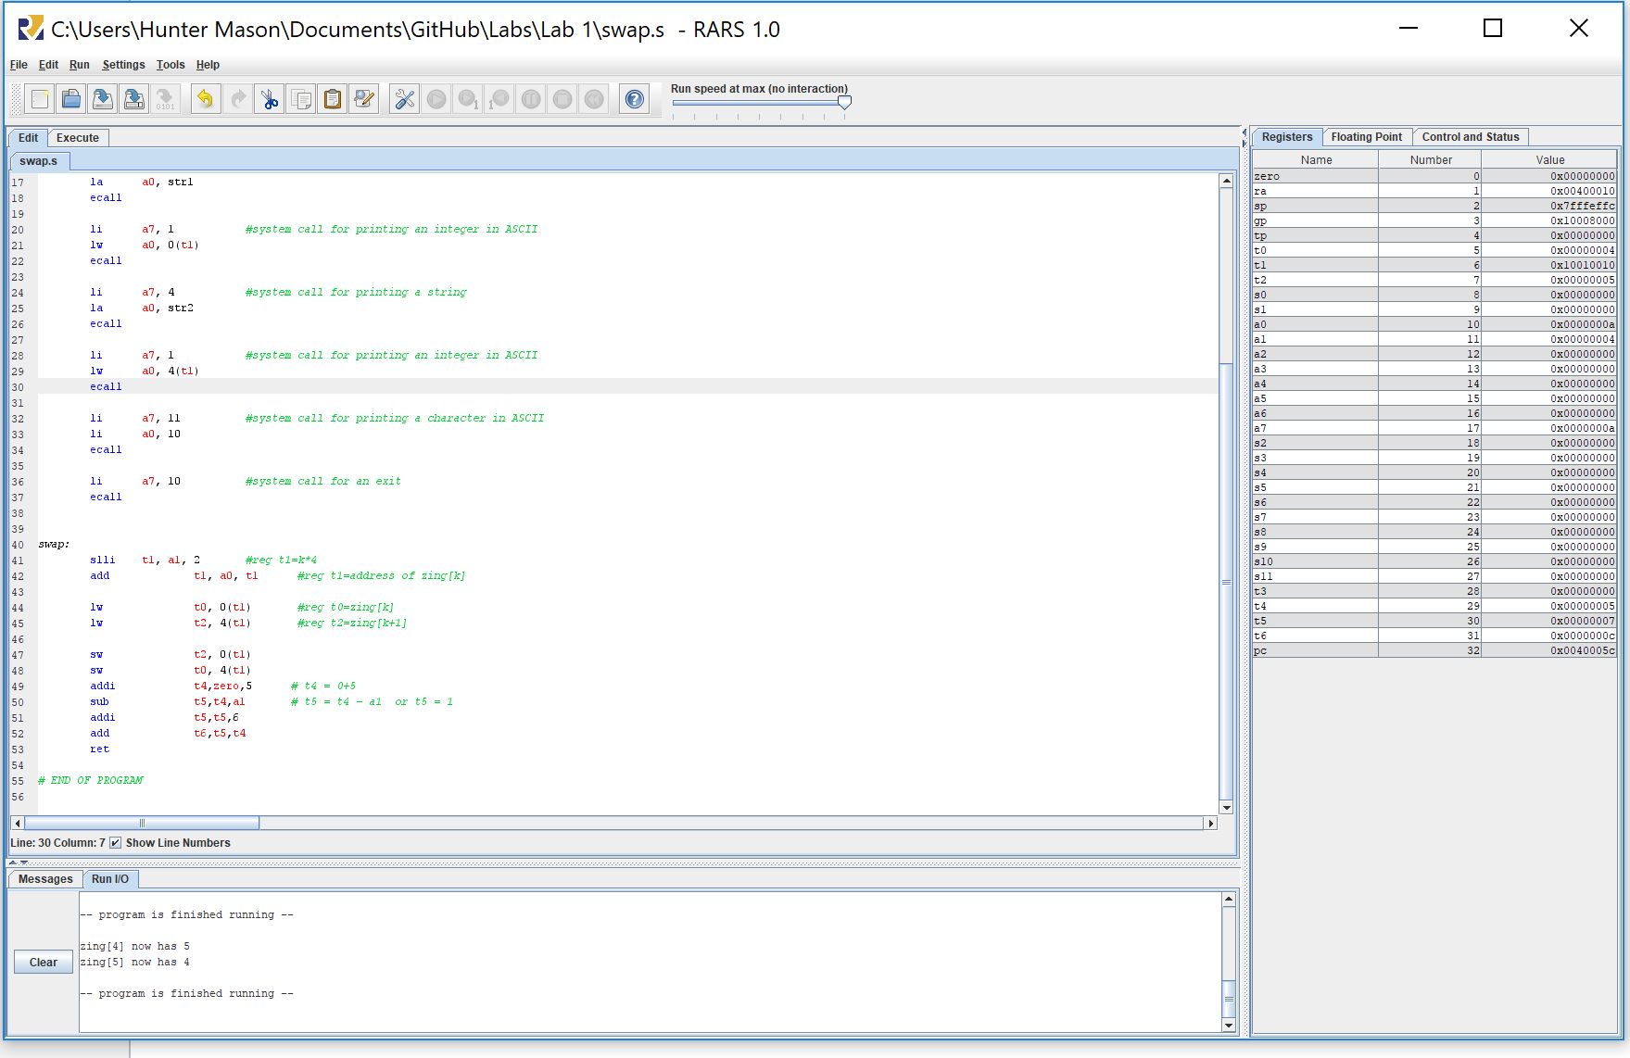

# Venus Introduction and Questions

The Zing array is stored at address 0x10000000.

Verification of the swap occurring properly at Zing’s address, the blue arrow is pointing out the 0x10000010 and 0x10000014 memory addresses where Zing[4] and Zing[5] are stored.

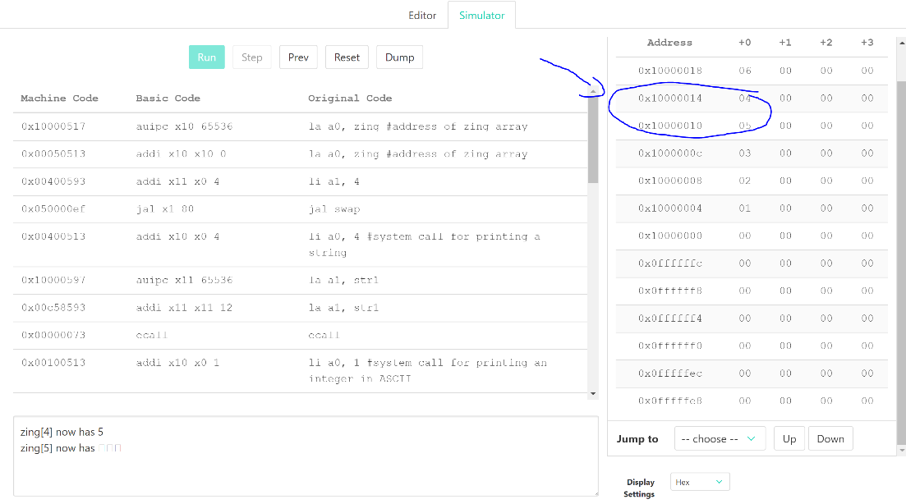

# ModelSim Introduction

The introduction files were easy to add to a project. I ran into issues getting the compiled code to simulate, using a shorter file tree and a different machine resolved this problem.

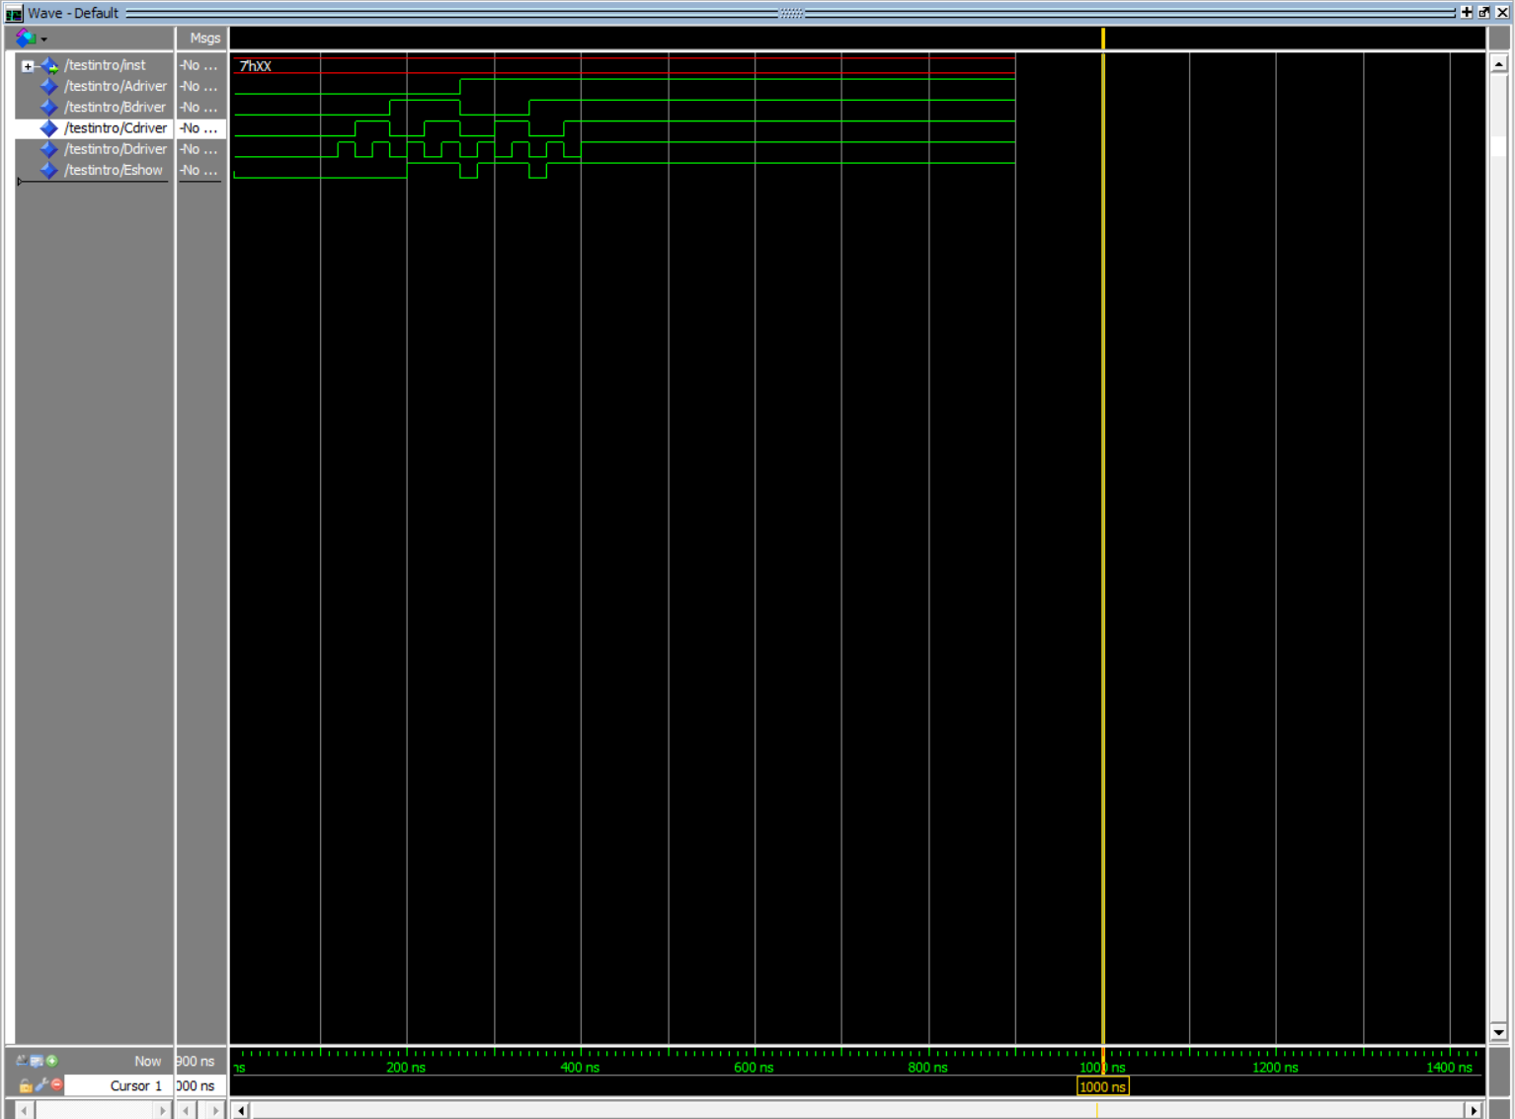

# GitHub Repository Link

https://github.com/HunterM982/Labs.git